Following are some of the important input devices which are used in a computer −

* Keyboard
* Mouse
* Joy Stick
* Light pen
* Track Ball
* Scanner
* Graphic Tablet
* Microphone
* Magnetic Ink Card Reader(MICR)
* Optical Character Reader(OCR)
* Bar Code Reader
* Optical Mark Reader(OMR)

Central Processing Unit (CPU) consists of the following features −

* CPU is considered as the brain of the computer.
* CPU performs all types of data processing operations.
* It stores data, intermediate results, and instructions (program).
* It controls the operation of all parts of the computer.

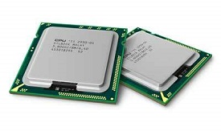

CPU itself has following three components.

* Memory or Storage Unit
* Control Unit
* ALU(Arithmetic Logic Unit)

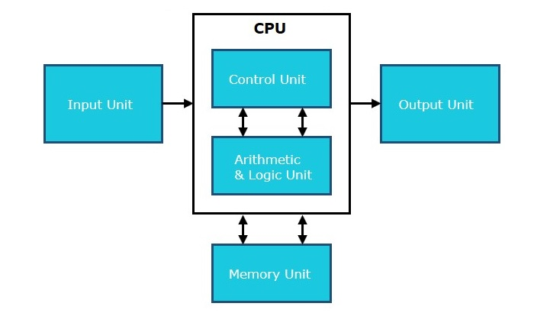

## Memory or Storage Unit

This unit can store instructions, data, and intermediate results. This unit supplies information to other units of the computer when needed. It is also known as internal storage unit or the main memory or the primary storage or Random Access Memory (RAM).

Its size affects speed, power, and capability. Primary memory and secondary memory are two types of memories in the computer. Functions of the memory unit are −

* It stores all the data and the instructions required for processing.
* It stores intermediate results of processing.
* It stores the final results of processing before these results are released to an output device.
* All inputs and outputs are transmitted through the main memory.

## Control Unit

This unit controls the operations of all parts of the computer but does not carry out any actual data processing operations.

Functions of this unit are −

* It is responsible for controlling the transfer of data and instructions among other units of a computer.
* It manages and coordinates all the units of the computer.
* It obtains the instructions from the memory, interprets them, and directs the operation of the computer.
* It communicates with Input/Output devices for transfer of data or results from storage.
* It does not process or store data.

## ALU (Arithmetic Logic Unit)

This unit consists of two subsections namely,

* Arithmetic Section
* Logic Section

### **Arithmetic Section**

Function of arithmetic section is to perform arithmetic operations like addition, subtraction, multiplication, and division. All complex operations are done by making repetitive use of the above operations.

### **Logic Section**

Function of logic section is to perform logic operations such as comparing, selecting, matching, and merging of data.

All types of computers follow the same basic logical structure and perform the following five basic operations for converting raw input data into information useful to their users.

|  |  |  |
| --- | --- | --- |
| **S.No.** | **Operation** | **Description** |
| 1 | Take Input | The process of entering data and instructions into the computer system. |
| 2 | Store Data | Saving data and instructions so that they are available for processing as and when required. |
| 3 | Processing Data | Performing arithmetic, and logical operations on data in order to convert them into useful information. |
| 4 | Output Information | The process of producing useful information or results for the user, such as a printed report or visual display. |
| 5 | Control the workflow | Directs the manner and sequence in which all of the above operations are performed. |



Input Unit

This unit contains devices with the help of which we enter data into the computer. This unit creates a link between the user and the computer. The input devices translate the information into a form understandable by the computer.

CPU (Central Processing Unit)

CPU is considered as the brain of the computer. CPU performs all types of data processing operations. It stores data, intermediate results, and instructions (program). It controls the operation of all parts of the computer.

CPU itself has the following three components −

* ALU (Arithmetic Logic Unit)
* Memory Unit
* Control Unit

Output Unit

The output unit consists of devices with the help of which we get the information from the computer. This unit is a link between the computer and the users. Output devices translate the computer's output into a form understandable by the users.

Computers can be broadly classified by their speed and computing power.

|  |  |  |
| --- | --- | --- |
| **S.No.** | **Type** | **Specifications** |
| 1 | PC (Personal Computer) | It is a single user computer system having moderately powerful microprocessor |
| 2 | Workstation | It is also a single user computer system, similar to personal computer however has a more powerful microprocessor. |
| 3 | Mini Computer | It is a multi-user computer system, capable of supporting hundreds of users simultaneously. |
| 4 | Main Frame | It is a multi-user computer system, capable of supporting hundreds of users simultaneously. Software technology is different from minicomputer. |
| 5 | Supercomputer | It is an extremely fast computer, which can execute hundreds of millions of instructions per second. |

## PC (Personal Computer)



A PC can be defined as a small, relatively inexpensive computer designed for an individual user. PCs are based on the microprocessor technology that enables manufacturers to put an entire CPU on one chip. Businesses use personal computers for word processing, accounting, desktop publishing, and for running spreadsheet and database management applications. At home, the most popular use for personal computers is playing games and surfing the Internet.

Although personal computers are designed as single-user systems, these systems are normally linked together to form a network. In terms of power, now-a-days high-end models of the Macintosh and PC offer the same computing power and graphics capability as low-end workstations by Sun Microsystems, Hewlett-Packard, and Dell.

## Workstation



Workstation is a computer used for engineering applications (CAD/CAM), desktop publishing, software development, and other such types of applications which require a moderate amount of computing power and relatively high quality graphics capabilities.

Workstations generally come with a large, high-resolution graphics screen, large amount of RAM, inbuilt network support, and a graphical user interface. Most workstations also have mass storage device such as a disk drive, but a special type of workstation, called diskless workstation, comes without a disk drive.

Common operating systems for workstations are UNIX and Windows NT. Like PC, workstations are also single-user computers like PC but are typically linked together to form a local-area network, although they can also be used as stand-alone systems.

## Minicomputer

It is a midsize multi-processing system capable of supporting up to 250 users simultaneously.

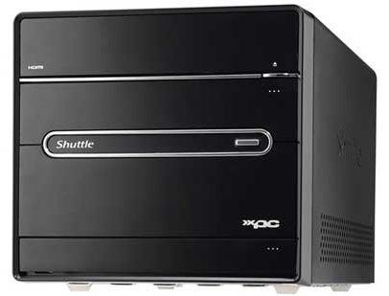

## Mainframe

Mainframe is very large in size and is an expensive computer capable of supporting hundreds or even thousands of users simultaneously. Mainframe executes many programs concurrently and supports many simultaneous execution of programs.



## Supercomputer

Supercomputers are one of the fastest computers currently available. Supercomputers are very expensive and are employed for specialized applications that require immense amount of mathematical calculations (number crunching).

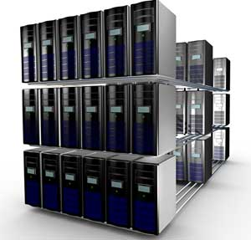

For example, weather forecasting, scientific simulations, (animated) graphics, fluid dynamic calculations, nuclear energy research, electronic design, and analysis of geological data (e.g. in petrochemical prospecting).

Generation in computer terminology is a change in technology a computer is/was being used. Initially, the generation term was used to distinguish between varying hardware technologies. Nowadays, generation includes both hardware and software, which together make up an entire computer system.

There are five computer generations known till date. Each generation has been discussed in detail along with their time period and characteristics. In the following table, approximate dates against each generation has been mentioned, which are normally accepted.

Following are the main five generations of computers.

|  |  |
| --- | --- |
| **S.No** | **Generation & Description** |
| 1 | [First Generation](https://www.tutorialspoint.com/computer_fundamentals/computer_first_generation.htm)  The period of first generation: 1946-1959. Vacuum tube based. |
| 2 | [Second Generation](https://www.tutorialspoint.com/computer_fundamentals/computer_second_generation.htm)  The period of second generation: 1959-1965. Transistor based. |
| 3 | [Third Generation](https://www.tutorialspoint.com/computer_fundamentals/computer_third_generation.htm)  The period of third generation: 1965-1971. Integrated Circuit based. |
| 4 | [Fourth Generation](https://www.tutorialspoint.com/computer_fundamentals/computer_fourth_generation.htm)  The period of fourth generation: 1971-1980. VLSI microprocessor based. |
| 5 | [Fifth Generation](https://www.tutorialspoint.com/computer_fundamentals/computer_fifth_generation.htm)  The period of fifth generation: 1980-onwards. ULSI microprocessor based. |

In this chapter, we will discuss the application of computers in various fields.

Business



A computer has high speed of calculation, diligence, accuracy, reliability, or versatility which has made it an integrated part in all business organizations.

Computer is used in business organizations for −

* Payroll calculations
* Budgeting
* Sales analysis
* Financial forecasting
* Managing employee database
* Maintenance of stocks, etc.

Banking



Today, banking is almost totally dependent on computers.

Banks provide the following facilities −

* Online accounting facility, which includes checking current balance, making deposits and overdrafts, checking interest charges, shares, and trustee records.
* ATM machines which are completely automated are making it even easier for customers to deal with banks.

Insurance

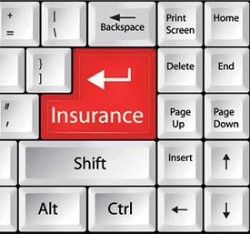

Insurance companies are keeping all records up-to-date with the help of computers. Insurance companies, finance houses, and stock broking firms are widely using computers for their concerns.

Insurance companies are maintaining a database of all clients with information showing −

* Procedure to continue with policies
* Starting date of the policies
* Next due installment of a policy
* Maturity date
* Interests due
* Survival benefits
* Bonus

Education



The computer helps in providing a lot of facilities in the education system.

* The computer provides a tool in the education system known as CBE (Computer Based Education).
* CBE involves control, delivery, and evaluation of learning.
* Computer education is rapidly increasing the graph of number of computer students.
* There are a number of methods in which educational institutions can use a computer to educate the students.
* It is used to prepare a database about performance of a student and analysis is carried out on this basis.

Marketing

In marketing, uses of the computer are following −



* **Advertising** − With computers, advertising professionals create art and graphics, write and revise copy, and print and disseminate ads with the goal of selling more products.
* **Home Shopping** − Home shopping has been made possible through the use of computerized catalogues that provide access to product information and permit direct entry of orders to be filled by the customers.

Healthcare

Computers have become an important part in hospitals, labs, and dispensaries. They are being used in hospitals to keep the record of patients and medicines. It is also used in scanning and diagnosing different diseases. ECG, EEG, ultrasounds and CT scans, etc. are also done by computerized machines.

Following are some major fields of health care in which computers are used.



* **Diagnostic System** − Computers are used to collect data and identify the cause of illness.
* **Lab-diagnostic System** − All tests can be done and the reports are prepared by computer.
* **Patient Monitoring System** − These are used to check the patient's signs for abnormality such as in Cardiac Arrest, ECG, etc.
* **Pharma Information System** − Computer is used to check drug labels, expiry dates, harmful side effects, etc.
* **Surgery** − Nowadays, computers are also used in performing surgery.

Engineering Design

Computers are widely used for Engineering purpose.

One of the major areas is CAD (Computer Aided Design) that provides creation and modification of images. Some of the fields are −



* **Structural Engineering** − Requires stress and strain analysis for design of ships, buildings, budgets, airplanes, etc.
* **Industrial Engineering** − Computers deal with design, implementation, and improvement of integrated systems of people, materials, and equipment.
* **Architectural Engineering** − Computers help in planning towns, designing buildings, determining a range of buildings on a site using both 2D and 3D drawings.

Military

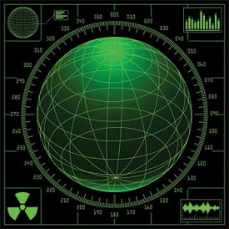

Computers are largely used in defence. Modern tanks, missiles, weapons, etc. Military also employs computerized control systems. Some military areas where a computer has been used are −

* Missile Control
* Military Communication
* Military Operation and Planning
* Smart Weapons

Communication

Communication is a way to convey a message, an idea, a picture, or speech that is received and understood clearly and correctly by the person for whom it is meant. Some main areas in this category are −



* E-mail
* Chatting
* Usenet
* FTP
* Telnet
* Video-conferencing

Government

Computers play an important role in government services. Some major fields in this category are −



* Budgets
* Sales tax department
* Income tax department
* Computation of male/female ratio
* Computerization of voters lists
* Computerization of PAN card
* Weather forecasting

## Functionalities of a Computer

If we look at it in a very broad sense, any digital computer carries out the following five functions −

**Step 1** − Takes data as input.

**Step 2** − Stores the data/instructions in its memory and uses them as required.

**Step 3** − Processes the data and converts it into useful information.

**Step 4** − Generates the output.

**Step 5** − Controls all the above four steps.

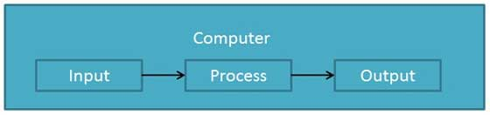

## Advantages of Computers

Following are certain advantages of computers.

### **High Speed**

* Computer is a very fast device.
* It is capable of performing calculation of very large amount of data.
* The computer has units of speed in microsecond, nanosecond, and even the picosecond.
* It can perform millions of calculations in a few seconds as compared to man who will spend many months to perform the same task.

### **Accuracy**

* In addition to being very fast, computers are very accurate.
* The calculations are 100% error free.
* Computers perform all jobs with 100% accuracy provided that the input is correct.

### **Storage Capability**

* Memory is a very important characteristic of computers.
* A computer has much more storage capacity than human beings.
* It can store large amount of data.
* It can store any type of data such as images, videos, text, audio, etc.

### **Diligence**

* Unlike human beings, a computer is free from monotony, tiredness, and lack of concentration.
* It can work continuously without any error and boredom.
* It can perform repeated tasks with the same speed and accuracy.

### **Versatility**

* A computer is a very versatile machine.
* A computer is very flexible in performing the jobs to be done.
* This machine can be used to solve the problems related to various fields.
* At one instance, it may be solving a complex scientific problem and the very next moment it may be playing a card game.

### **Reliability**

* A computer is a reliable machine.
* Modern electronic components have long lives.
* Computers are designed to make maintenance easy.

### **Automation**

* Computer is an automatic machine.
* Automation is the ability to perform a given task automatically. Once the computer receives a program i.e., the program is stored in the computer memory, then the program and instruction can control the program execution without human interaction.

### **Reduction in Paper Work and Cost**

* The use of computers for data processing in an organization leads to reduction in paper work and results in speeding up the process.
* As data in electronic files can be retrieved as and when required, the problem of maintenance of large number of paper files gets reduced.
* Though the initial investment for installing a computer is high, it substantially reduces the cost of each of its transaction.

## Disadvantages of Computers

Following are certain disadvantages of computers.

### **No I.Q.**

* A computer is a machine that has no intelligence to perform any task.
* Each instruction has to be given to the computer.
* A computer cannot take any decision on its own.

### **Dependency**

* It functions as per the user’s instruction, thus it is fully dependent on humans.

### **Environment**

* The operating environment of the computer should be dust free and suitable.

### **No Feeling**

* Computers have no feelings or emotions.
* It cannot make judgment based on feeling, taste, experience, and knowledge unlike humans.

Hardware represents the physical and tangible components of a computer, i.e. the components that can be seen and touched.

Examples of Hardware are the following −

* **Input devices** − keyboard, mouse, etc.
* **Output devices** − printer, monitor, etc.
* **Secondary storage devices** − Hard disk, CD, DVD, etc.
* **Internal components** − CPU, motherboard, RAM, etc.



Relationship between Hardware and Software

* Hardware and software are mutually dependent on each other. Both of them must work together to make a computer produce a useful output.
* Software cannot be utilized without supporting hardware.
* Hardware without a set of programs to operate upon cannot be utilized and is useless.
* To get a particular job done on the computer, relevant software should be loaded into the hardware.
* Hardware is a one-time expense.
* Software development is very expensive and is a continuing expense.
* Different software applications can be loaded on a hardware to run different jobs.
* A software acts as an interface between the user and the hardware.
* If the hardware is the 'heart' of a computer system, then the software is its 'soul'. Both are complementary to each other.

A port is a physical docking point using which an external device can be connected to the computer. It can also be programmatic docking point through which information flows from a program to the computer or over the Internet.

Characteristics of Ports

A port has the following characteristics −

* External devices are connected to a computer using cables and ports.
* Ports are slots on the motherboard into which a cable of external device is plugged in.
* Examples of external devices attached via ports are the mouse, keyboard, monitor, microphone, speakers, etc.

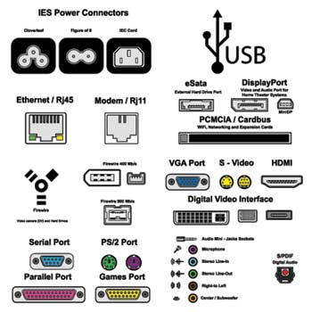

Let us now discuss a few important types of ports −

Serial Port

* Used for external modems and older computer mouse
* Two versions: 9 pin, 25 pin model
* Data travels at 115 kilobits per second

Parallel Port

* Used for scanners and printers
* Also called printer port
* 25 pin model
* IEEE 1284-compliant Centronics port

PS/2 Port

* Used for old computer keyboard and mouse
* Also called mouse port
* Most of the old computers provide two PS/2 port, each for the mouse and keyboard
* IEEE 1284-compliant Centronics port

Universal Serial Bus (or USB) Port

* It can connect all kinds of external USB devices such as external hard disk, printer, scanner, mouse, keyboard, etc.
* It was introduced in 1997.
* Most of the computers provide two USB ports as minimum.
* Data travels at 12 megabits per seconds.
* USB compliant devices can get power from a USB port.

VGA Port

* Connects monitor to a computer's video card.
* It has 15 holes.
* Similar to the serial port connector. However, serial port connector has pins, VGA port has holes.

Power Connector

* Three-pronged plug.
* Connects to the computer's power cable that plugs into a power bar or wall socket.

Firewire Port

* Transfers large amount of data at very fast speed.
* Connects camcorders and video equipment to the computer.
* Data travels at 400 to 800 megabits per seconds.
* Invented by Apple.
* It has three variants: 4-Pin FireWire 400 connector, 6-Pin FireWire 400 connector, and 9-Pin FireWire 800 connector.

Modem Port

* Connects a PC's modem to the telephone network.

Ethernet Port

* Connects to a network and high speed Internet.
* Connects the network cable to a computer.
* This port resides on an Ethernet Card.
* Data travels at 10 megabits to 1000 megabits per seconds depending upon the network bandwidth.

Game Port

* Connect a joystick to a PC
* Now replaced by USB

Digital Video Interface, DVI port

* Connects Flat panel LCD monitor to the computer's high-end video graphic cards.
* Very popular among video card manufacturers.

Sockets

* Sockets connect the microphone and speakers to the sound card of the computer.

Whether you’re a one-person business operating out of your kitchen, or a billion-dollar company on Wall Street, the expectation is the same. Your business documents must be the paragon of professionalism and competence.

Here's a finished, formatted business document that uses basic text formatting in Word.

This expectation shouldn’t be a cause for worry. With applications like Microsoft Word you can create professional-looking documents with your own computer. Through the years, Word has become more powerful, yet more intuitive. Anyone with basic computer skills can [**use Word to create well-designed documents**](https://elements.envato.com/graphic-templates/print-templates/word).

In this article, you'll learn how to format text in Word to make your business documents easier to read and understand. You’ll also pick up tips on how to make sure your formatting doesn’t look amateurish—even if you're getting started with Word.

## Formatting Text in Word

***Formatting text***in Microsoft Word refers to **controlling how text appears in your document.**This includes the size, color, and font of the text. It also covers text alignment, spacing, and letter case.

Microsoft Word styles make it easy to change and apply styles throughout a document. **A “style”** is a **set of formatting settings applied to a specific kind of text**.

For example, you can set up a style for headings that's bold, 14 points, aligned left, and uses the Tahoma font. This means all text in your document with the heading style will be formatted the same way. You don’t have to manually format each heading in your document.

In this post, you’ll see how to use MS Word styles.

## How to Format Text in Word

To show you how to format text in Word, we’ll walk through formatting a completely unformatted business document file.

This is what my marketing report looks like without any formatting in Word:

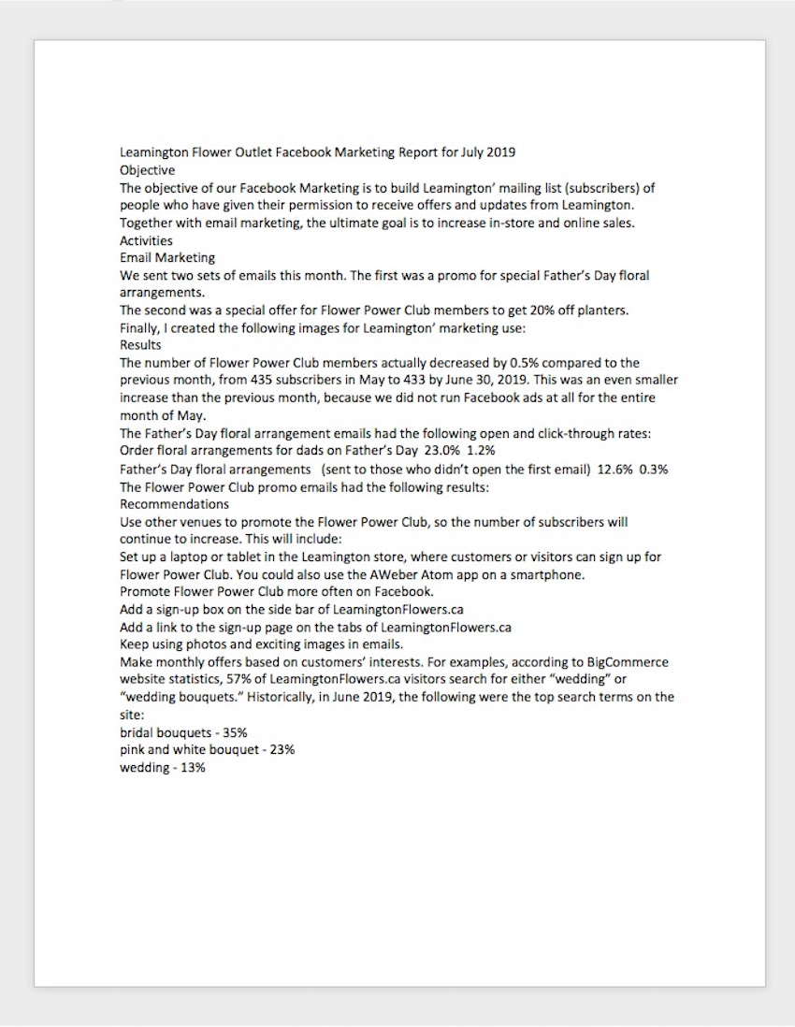Notice how the unformatted text looks in Word. It's not very engaging or interesting.

As you can see, it’s plain and boring. Nobody would be inspired to read it, let alone act on the findings of the report!

Some basic Word text formatting can fix that.

### 1. How to Apply Typographic Emphasis

1. For starters, let’s use typographic emphasis (bold, italic, underline) to make the report title stand out.

To do this, select the text you want to emphasize. Click on the bold button on the Microsoft Word ribbon.

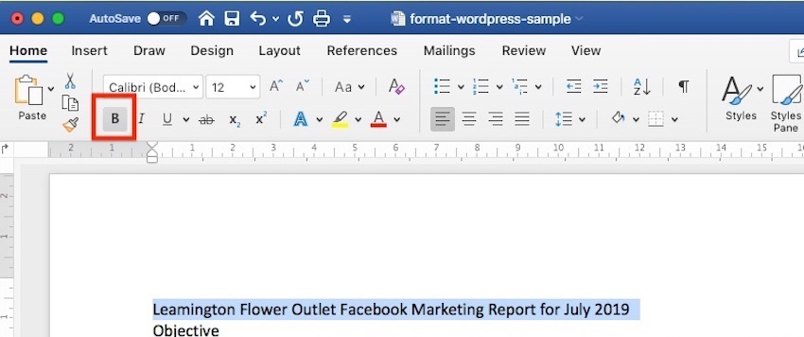Applying bold to Word text helps it to stand out.

Note that the ribbon also has the buttons to apply italic, underline, strikethrough, and other formatting effects for text. Follow the same steps to apply those effects.

2. Now, let’s change the font, font size, and color of the title.

Again, select the text. Click the drop-down arrow on the font section of the ribbon, then select the font you want to apply. In this case, I’m using Arial bold.

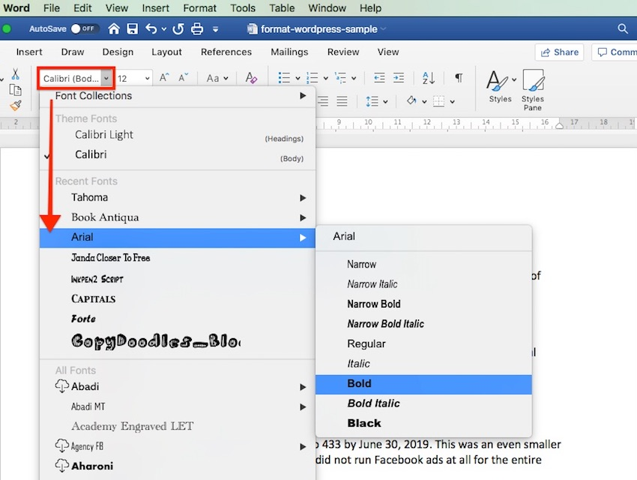You can also change the font when you format text in Word.

3. To change the font size, highlight the text. Click the drop-down arrow on the font size indicator on the ribbon. Click on the font size of your choice.

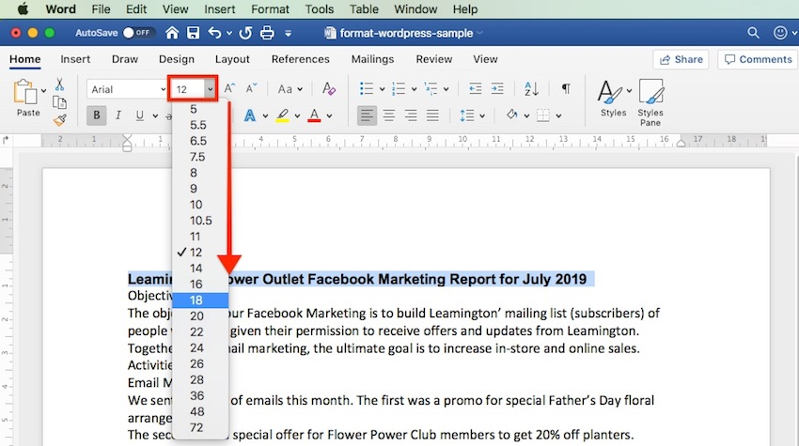Use basic formatting for Word to change the size of the text.

Or, after highlighting the text, you can type the font size into the font size indicator on the ribbon. This is especially useful when the font size you want isn't available in the font size selector.

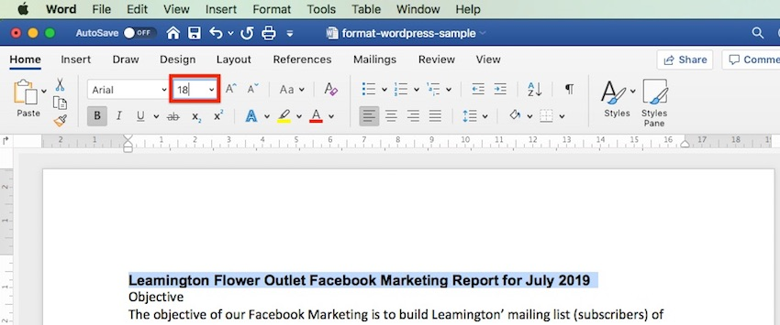The highlighted text is the text we've been formatting. Use the font size indicator to change the text size.

4. You can also use the **Increase Font Size** or **Decrease Font Size** buttons on the ribbon to quickly change the font size.

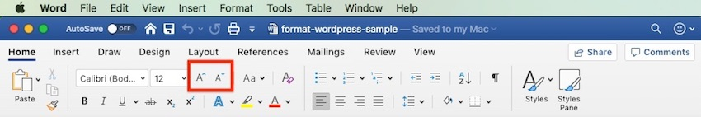Another way to change the Word style is using the I**ncrease Font Size**or **Decrease Font Size**buttons.

5. We can easily change the font color as well.

Highlight the text, then click the down arrow beside the **Font Color** selector. Click on the color of your choice.

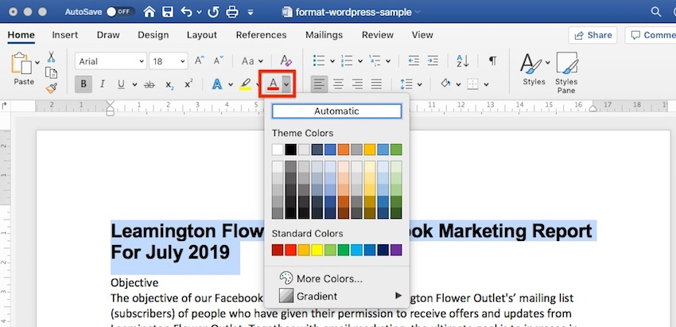You can also change the text color in Microsoft Word.

Choose **More Colors…** if you wish to apply a custom color.

### 2. How to Change Capitalization in Word

Microsoft Word also allows you to easily and quickly change the capitalization of your text. For example, if we want to make the title all uppercase, we don’t have to retype it.

Highlight the title, then click the **Change Case** button on the ribbon.

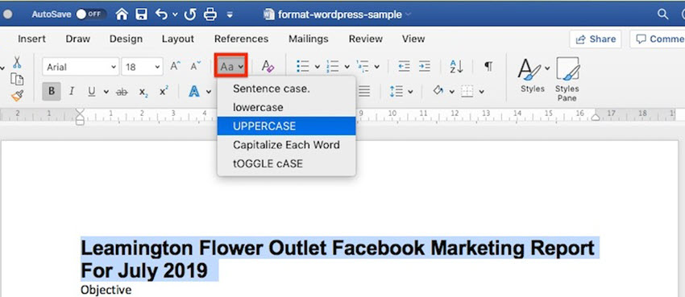The **Change Case**button provides a shortcut for formatting text in Word.

Or, highlight the text, go to **Format** > **Change Case…**

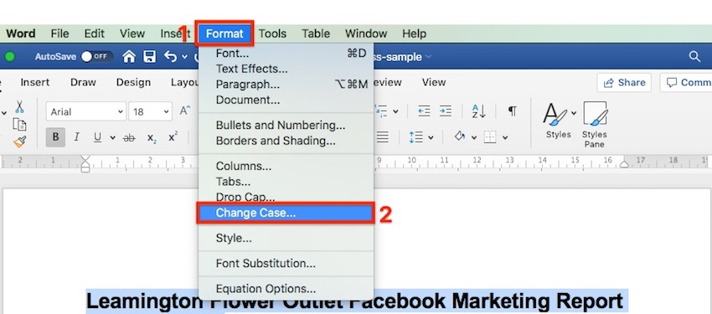You can also change the case in Word by using the menu option.

… then click on the radio button for the case you want to apply. Click **OK**.

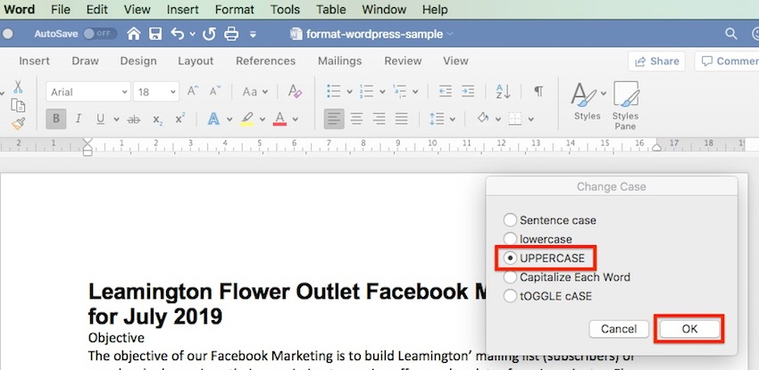The title is an important part of your document. So, how you format it is important.

Now the title is looking much better. It’s the most prominent part of the document and commands the reader’s attention. However, we can still improve its readability.

Advertisement

### 3. How to Format Paragraphs

One way to make your document easier to read is by increasing white space around lines and paragraphs.

1. To adjust the line spacing, select the text. Click on the arrow on the **Line and Paragraph Spacing** button. Select the line spacing you wish to apply.

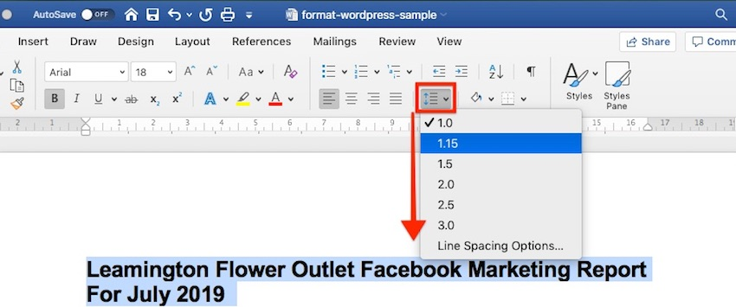One MS Word format essential is knowing how to change the spading between lines and paragraphs.

2. To change the spacing around a paragraph, select the paragraph. Click on the arrow on the **Line and Paragraph Spacing** button > **Line Spacing Options…**. Then, type the amount of spacing before and after the paragraph. (Tip: You can adjust other settings from this dialog box as well.)

For the title, I'll add a generous amount of space after the paragraph, to set it apart from the rest of the document.

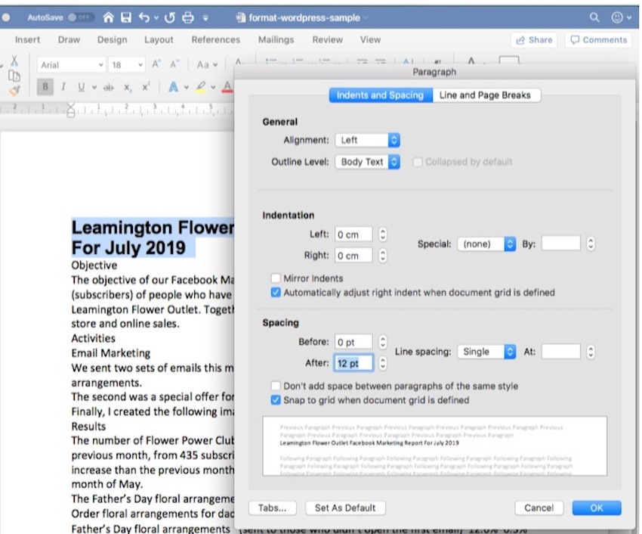A good way to set the title apart from the text is to increase the line spacing after it.

3. Finally, let’s change the alignment of the title. Select the text, click on either the **Align Left**, **Center Text**, **Align Right**, or **Justify** button on the ribbon. Since this is a title, let’s use **Center Text**.

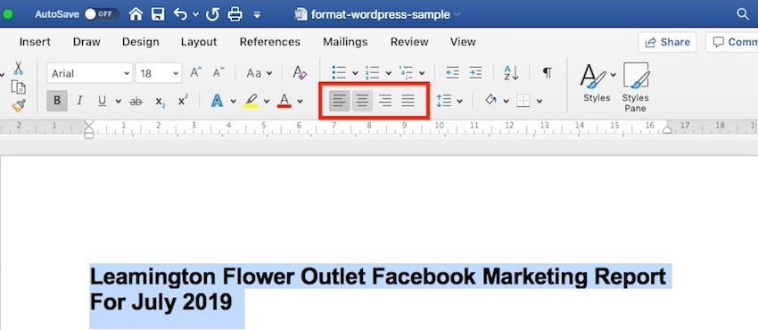You can also change the text alignment on the page in Word.

These simple formatting effects make the title stand out from the rest of the document.

### 4. How to Work With MS Word Styles

As much as Word makes it easy to format text, if you need to apply formatting effects on the entire document, the process becomes tedious.

Word solves that through styles. MS Word Styles allow you to define a set of formatting commands and apply them automatically to every item in the document with that style.

Let’s look at a specific example:

#### 1. How to Modify a Paragraph Style

Let’s follow the steps above to define a style for the main headings of the report with the following characteristics:

* Font: Arial
* Size: 14 points
* Color: Blue-grey
* Typographic Emphasis: Bold
* Case: Capitalize each word
* Alignment: Left
* Line spacing: Single
* Paragraph spacing: 6 pts before paragraph, 0 pts after paragraph

It would look like this:

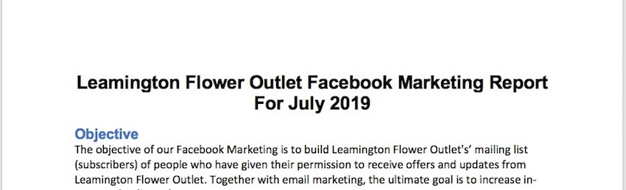Notice the various ways I've change the word style in this document.

One way to apply this exact formatting on every main heading is to modify the existing Heading 1 style in our document. Place your cursor anywhere in the main heading. Go to **Styles**, right-click on Heading 1, then choose **Update Heading 1 to Match Selection**.

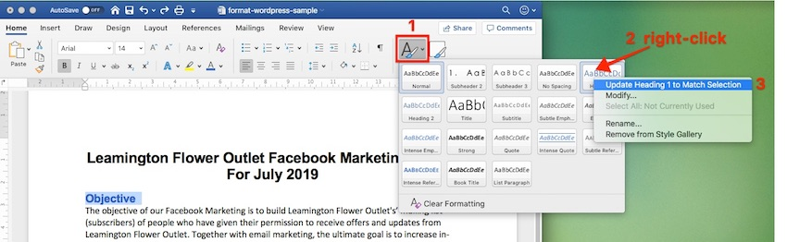Use Microsoft Word styles to change heading format quickly.

You can also modify any style by going to **Format** > **Style…**. The **Style** dialog box opens.

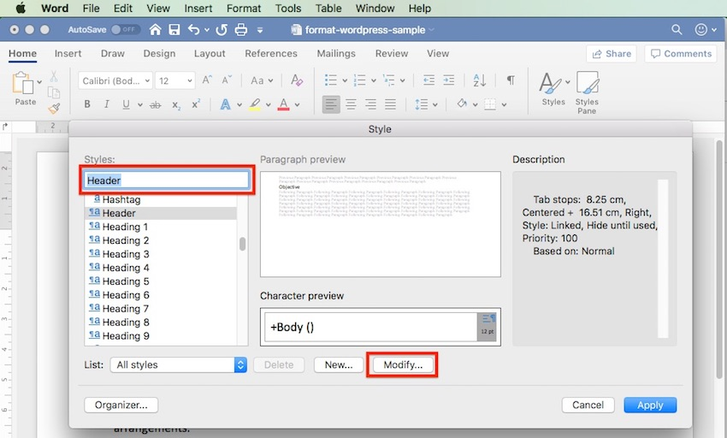You can also change Word style through the menu.

Select the style you want to modify from the **Style** list. This gives you a preview of the paragraph and character, as well as a description of the current style settings of the selected style.

Click **Modify…**. The **Modify Style** dialog box pops up.

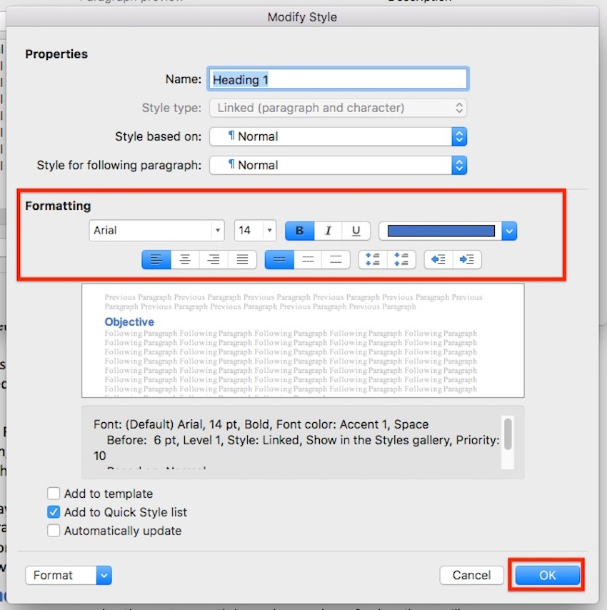Here you see the various ways to change text format using the Word style tags.

Change the text and paragraph format settings. You can control the font, font size, font color, typographic emphasis, alignment, and spacing. When you’re done, click **OK**.

#### 2. How to Apply a Paragraph Style

Now, go to each main heading in the document and apply the Heading 1 style to it. Place the cursor on a heading, go to **Styles** > **Heading 1.**

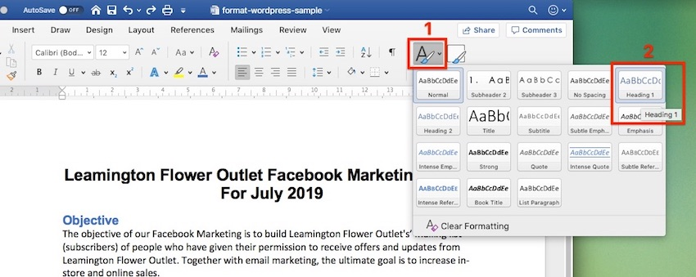Microsoft Word styles make changing a text quick and easy.

The selected text instantly takes on the formatting of Heading 1.

Notice how the formatting has changed.

#### 3. How to Create a List Paragraph Style

You can also create a new paragraph style from scratch, instead of modifying an existing one. To demonstrate, let’s create a list-type paragraph style.

1. Go to **Format** > **Style…**. Fill in the **Properties** section of the dialog box that opens. **For Style based on**, you may wish to use one of the pre-existing list styles as a starting point.

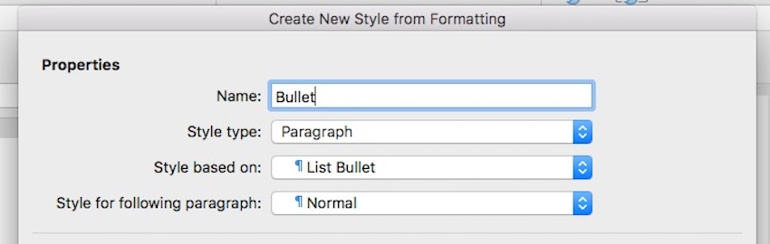You can also create new styles to format text in Word.

2. Next, change the formatting options. The box below gives you a preview of what the list paragraph would look like with those settings. There's also a summary of the formatting properties you’ve specified.

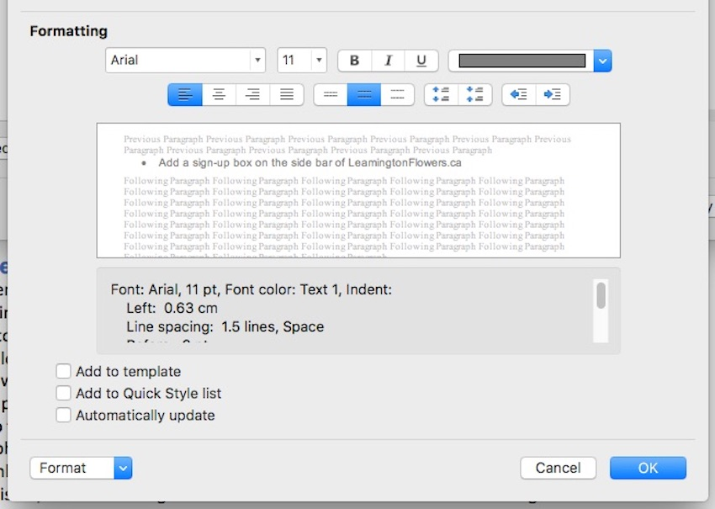Here's a preview of a new style I'm creating.

You also have the option to do the following for this style:

* **Add to template.** Adds the style you’re creating to the document template.
* **Add to Quick Style list**. Shows the new style to the Quick Style list, making it quickly accessible from the ribbon.
* **Automatically update.** Automatically updates the style when you manually format a paragraph with that style.

When you’re happy with the settings you’ve made, click **OK**. Notice how the new Bullet style you created is now included in the **Quick Style** popup.

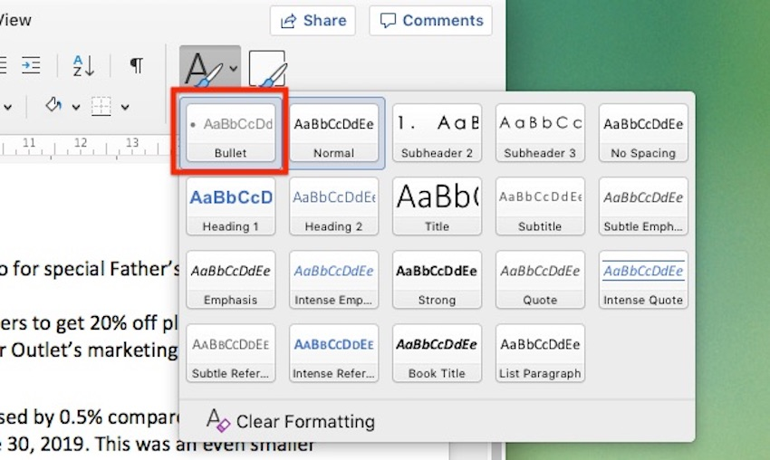Any styles you create are added to the **Quick Style** popup.

Once the bullet style is applied, our list now looks like this:

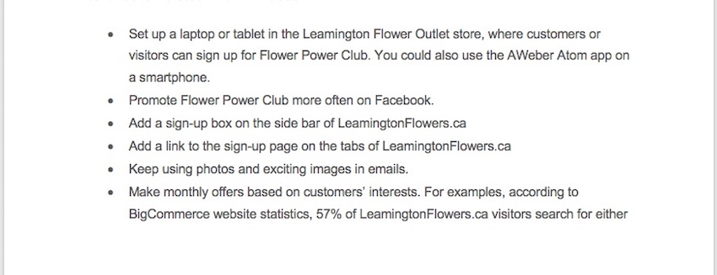The new style has created a bulleted list format.

#### 4. How to Use Character Styles in Microsoft Word

You can also define a style to an individual word or a block of text, rather than a paragraph. In the next example, I’d like to apply a character style for every URL in the document.

1. Select the text. Then, go to **Format** > **Styles…**. From the **Style** dialog, click **New…**. The **Create New Style from Formatting** dialog opens.

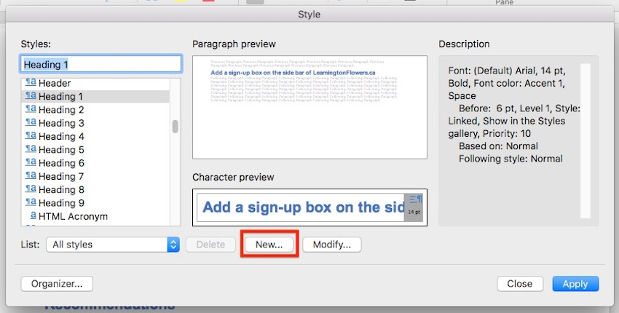You can create unique MS Word styles for a section of text called **Character**styles.

2. Give the new character style a name. For **Style type**, choose **Character**. Then, make the formatting settings you want to apply to this character. Note that you can't change alignment and spacing for a character style. The preview box shows you a sneak peek of the text based on the settings you specified.

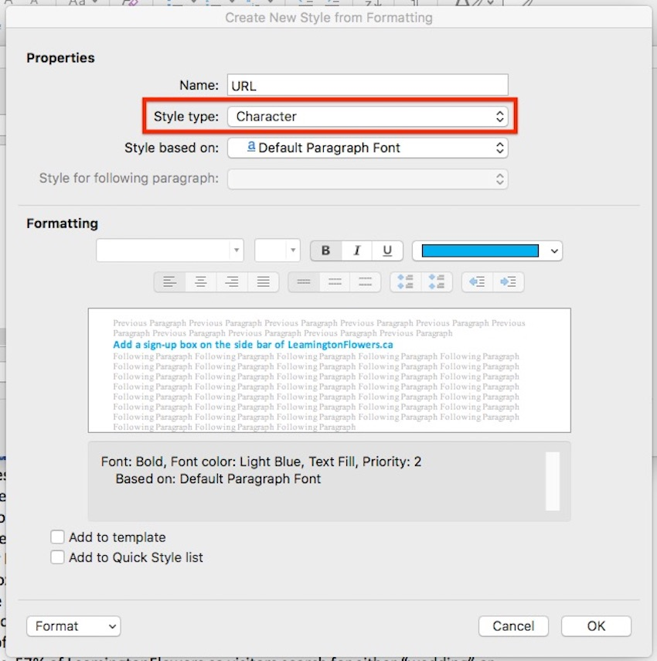Name your character style.

3. When you’re done, click **OK**.

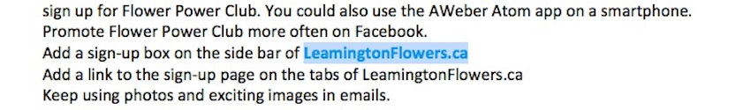

To apply the character style, place your cursor in a word or select a set of words. Go to **Format** > **Style…**. Find the character style you wish to apply. Click **Apply**.

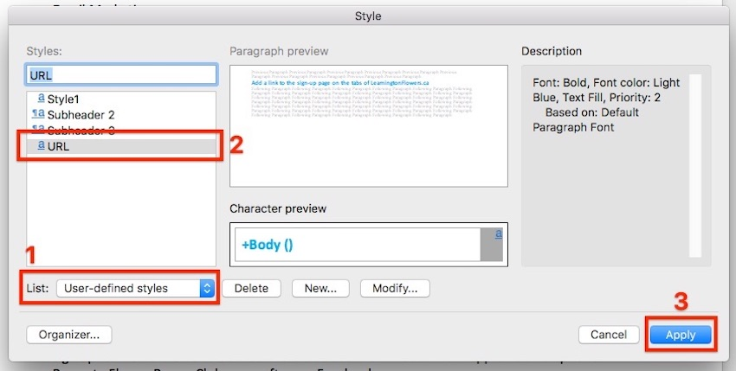When you're ready, apply the new character style to the selected text.

***Tip***: To quickly find the MS Word styles you’ve created, for **List**, choose User-defined styles.

#### 5. How to Use Table Styles in Word

We can also define a table style to provide a consistent look to the tables in our document.

1. Create the table. Go to **Insert** > **Table…**, then indicate the number of columns and rows you need in your table (you can always add or remove these later). Click **OK**.

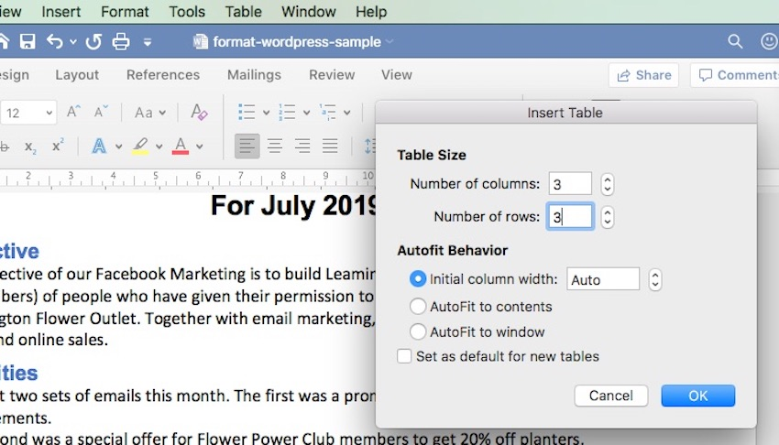Tables are a great way to format text in Word and add a visual element to the document.

2. Add your text to the table. If necessary, click and drag any of the borderlines to adjust the width or a column, or the height of a row.

3. To apply a table style, click anywhere on the table, then go to **Table Design**. The **Table Design** ribbon appears.

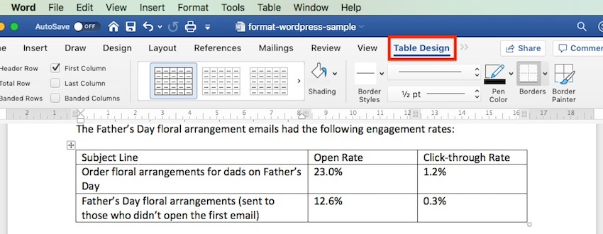You can use some pre-defined table Microsoft Word table styles to format your table.

4. Click on the down-arrow for table styles to display the table styles gallery.

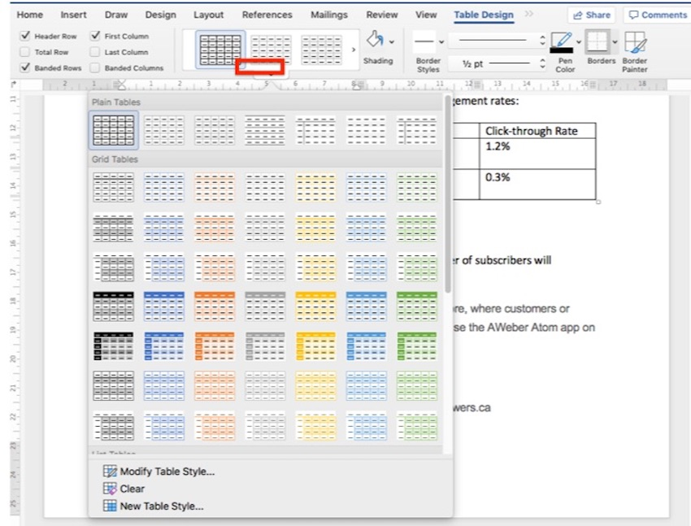As you can see, there are quite a few MS Word table styles to choose from.

5. Click on any style to apply it to your table.

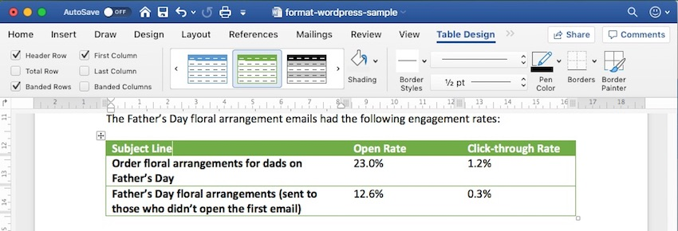Here's a table with a pre-defined MS Word table style applied.

Expand the table styles gallery again to change the existing style, clear the style you applied, or create your own table style.

## Discover Great Microsoft Word Templates for 2020

Some experts say it’s a good idea to set up your formatting styles in Word first before typing or copying the text into the document. One quick way to do this is by starting with a Microsoft Word template. Templates come pre-formatted by professional designers to look current and impressive.

You can find thousands of [**Word templates**](https://elements.envato.com/graphic-templates/print-templates/word) for all kinds of business documents in Envato Elements.

**[](https://elements.envato.com/graphic-templates/print-templates/word)**[**Print templates for Microsoft Word**](https://elements.envato.com/graphic-templates/print-templates/word) have been designed and formatted by professional designers.

**For a small monthly subscription fee, you get unlimited downloads of all the templates at Elements.**You also have unlimited access to everything else in the Elements catalog:

* presentation templates
* web templates
* fonts
* photos
* graphics
* other digital assets

Use as many of these assets as you want, as often as you want, without paying more. This makes Elements a terrific source for all the creative assets you need to create remarkable marketing and communication materials.

You can also pay as you go at GraphicRiver. This marketplace also offers a huge library of [**templates for Microsoft Word**](https://graphicriver.net/graphics-with-microsoft+word-in-print-templates) and other digital assets for all your marketing and communication needs. The difference is, you only pay each time you use an item. This can be a very economical option.

Below are some of the best print templates for Word available on Envato Elements and GraphicRiver:

[[](https://business.tutsplus.com/articles/ms-word-business-proposal-templates--cms-33418)](https://business.tutsplus.com/articles/ms-word-business-proposal-templates--cms-33418)

**[25 Microsoft MS Word Business Proposal Templates to Make Deals in 2022](https://business.tutsplus.com/articles/ms-word-business-proposal-templates--cms-33418)**

[[](https://business.tutsplus.com/articles/ms-word-business-proposal-templates--cms-33418)](https://business.tutsplus.com/articles/ms-word-business-proposal-templates--cms-33418)

[Brenda Barron](https://business.tutsplus.com/articles/ms-word-business-proposal-templates--cms-33418)

[19 Dec 2021](https://business.tutsplus.com/articles/ms-word-business-proposal-templates--cms-33418)

[[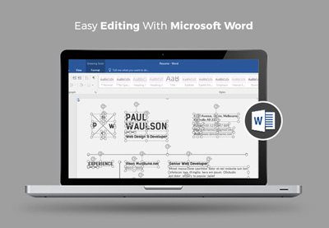](https://business.tutsplus.com/articles/professional-ms-word-resume-templates--cms-27507)](https://business.tutsplus.com/articles/professional-ms-word-resume-templates--cms-27507)

**[40 Pro MS Word Resume Templates, Simple CV Design Formats for 2022 (+ Video)](https://business.tutsplus.com/articles/professional-ms-word-resume-templates--cms-27507)**

[[](https://business.tutsplus.com/articles/professional-ms-word-resume-templates--cms-27507)](https://business.tutsplus.com/articles/professional-ms-word-resume-templates--cms-27507)

[Marc Schenker](https://business.tutsplus.com/articles/professional-ms-word-resume-templates--cms-27507)

[13 Jan 2022](https://business.tutsplus.com/articles/professional-ms-word-resume-templates--cms-27507)

[[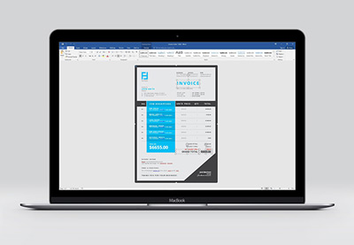](https://business.tutsplus.com/articles/simple-invoice-templates-made-for-microsoft-word--cms-27321)](https://business.tutsplus.com/articles/simple-invoice-templates-made-for-microsoft-word--cms-27321)

**[20 Best Simple Microsoft Word Invoice Design Templates for 2022](https://business.tutsplus.com/articles/simple-invoice-templates-made-for-microsoft-word--cms-27321)**

[[](https://business.tutsplus.com/articles/simple-invoice-templates-made-for-microsoft-word--cms-27321)](https://business.tutsplus.com/articles/simple-invoice-templates-made-for-microsoft-word--cms-27321)

[Marc Schenker](https://business.tutsplus.com/articles/simple-invoice-templates-made-for-microsoft-word--cms-27321)

[09 Sep 2021](https://business.tutsplus.com/articles/simple-invoice-templates-made-for-microsoft-word--cms-27321)

After downloading any of these Microsoft Word templates, you can apply what you’ve learned about formatting text in Word. This way, you can personalize the template so that it aligns with your visual branding and preferences. You now know how to take any Word template and make it your own!

Advertisement

## 5 Top FAQs on Formatting Text in Microsoft Word

Below are some of the questions that come up as people format text in Word.

### 1. How Do You Make a Word Document Easier for the Reader to Scan?

Your primary goal when formatting text in Word is to make it easy for people to scan, read, and understand the content of the document. The different formatting options in Word help you achieve this:

* Use **typographic emphasis** like bold, italics, and underline to emphasize specific text and add variety to your document.
* Break up the document into **sections with headings** and sub-headings to help the reader scan and navigate their way through it.
* Use either **bulleted or numbered lists** where appropriate to shorten paragraphs and make lists easier to comprehend.
* Set up **line and paragraph spacing** so that there’s plenty of white spaces throughout the document.

### 2. How Many Fonts Should I Use in a Word Document?

It’s easy—and fun—to apply different fonts in Word. Too easy, in fact, that you could end up overwhelming your reader and making your document look like someone played with the formatting.

Avoid this by sticking to a maximum of two different fonts in a single document. For instance, you could choose a sans serif font for your title and headings, and a serif font for all other text. You could even use one font for the entire document, relying on typographical emphasis and color to distinguish different types of text from each other.

### 3. Why Should I Use Microsoft Word Text Styles?

Use Microsoft Word text styles because they let you apply formatting settings globally throughout your document. This is important in long documents, where formatting each line or paragraph is too onerous. With text styles, you only need to determine what style you want for each piece of text. Word will do the rest.

### 4. How Can I Make My Document Formatting Consistent?

Using MS Word styles, as you’ve learned in this article, is an easy way to make your document formatting consistent. You decide and set how you want each type of text to be formatted. Then you can apply those styles consistently through your entire document.

Beyond Microsoft Word styles, also make sure that the recurring parts of your document are consistent as well. These include your headers and footers, for example. You must also be consistent with the placement of images: Do they have borders? Are they always within the document’s margins or do they bleed to the edge of the page?

When you use a [**Word template**](https://elements.envato.com/graphic-templates/print-templates/word), these design decisions are already made for you. So, if you want a consistent design without all the hard work, then starting with a template for Word is the way to go.

### 5. How do You Copy text into Word without also copying junk code?

When you copy text from one application and paste it into Word, you run the risk of also copying the underlying formatting code for it. This code or set of formatting commands is invisible so you won’t know you’re copying it inadvertently. This can mess up your formatting in Word. Soon, you’ll be pulling your hair wondering why Word won’t “follow” your commands.

To avoid this grief, make sure you strip all formatting when you copy and paste the text into Word. Here’s how: Copy the text. In Word, click **Edit** > **Paste and Match Style**.

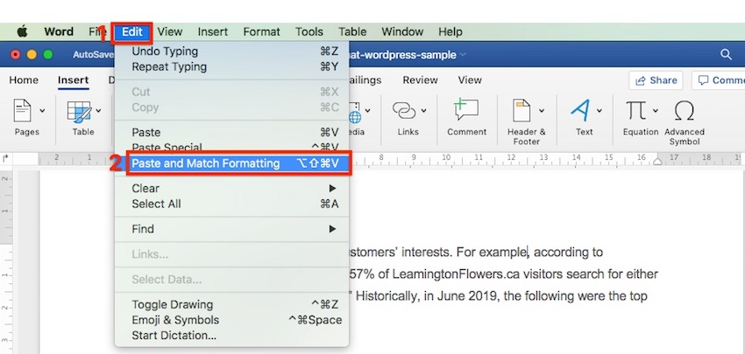

That’s all there is to it!

## Using Microsoft Word, Style Your Business Document for Maximum Impact

You’ve learned how to format a document in Word to make it easier to scan and read. Good formatting is also essential to make sure the final document represents you and your business in a favorable light.

You’ve seen how doable formatting is, even if you’re starting from scratch with completely unformatted text. You’ve also discovered that you can rely on professional designers to make the formatting decisions for you by starting with a template for Word.

**For unlimited downloads of**[**print templates for Word**](https://elements.envato.com/graphic-templates/print-templates/word)**at a fixed subscription fee, look to Envato Elements.** Here, you can also have your fill of fonts, icons, photos, and other design assets you’ll need without having to pay more. Or, get your premium [**Word templates**](https://graphicriver.net/graphics-with-microsoft+word-in-print-templates) from GraphicRiver on a pay-per-use basis. You also get a wide range of choices without having to commit to a subscription.

With Microsoft Word styles and formatting tools, there’s no more excuse to have poorly designed business documents. Make your next business document one you’ll be proud of.

# ntroduction to Microsoft Excel 101: Notes About MS Excel

By[Susan Gipson](https://www.guru99.com/author/susan)UpdatedDecember 23, 2022

In this Microsoft Excel tutorial, we will learn the Microsoft Exel basics. These Microsoft Excel notes will help you learn every MS Excel concepts. Let’s start with the introduction:

## What is Microsoft Excel?

**Microsoft Excel** is a spreadsheet program used to record and analyze numerical and statistical data. Microsoft Excel provides multiple features to perform various operations like calculations, pivot tables, graph tools, macro programming, etc. It is compatible with multiple OS like Windows, macOS, Android and iOS.

A Excel spreadsheet can be understood as a collection of columns and rows that form a table. Alphabetical letters are usually assigned to columns, and numbers are usually assigned to rows. The point where a column and a row meet is called a cell. The address of a cell is given by the letter representing the column and the number representing a row.

### Why Should I Learn Microsoft Excel?

We all deal with numbers in one way or the other. We all have daily expenses which we pay for from the monthly income that we earn. For one to spend wisely, they will need to know their income vs. expenditure. Microsoft Excel comes in handy when we want to record, analyze and store such numeric data. Let’s illustrate this using the following image.

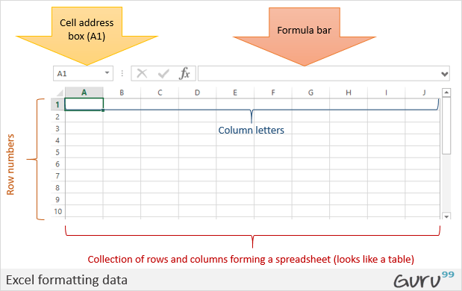

EXPLORE MORELearn Java Programming with Beginners Tutorial08:32Linux Tutorial for Beginners: Introduction to Linux Operating...01:35What is Integration Testing Software Testing Tutorial03:04What is JVM (Java Virtual Machine) with Architecture JAVA...02:24How to write a TEST CASE Software Testing Tutorial01:08Seven Testing Principles Software Testing05:01Linux File Permissions Commands with Examples13:29How to use Text tool in Photoshop CC Tutorial08:32What is NoSQL Database Tutorial02:00Important Linux Commands for Beginners Linux Tutorial15:03

### Where can I get Microsoft Excel?

There are number of ways in which you can get Microsoft Excel. You can buy it from a hardware computer shop that also sells software. Microsoft Excel is part of the Microsoft Office suite of programs. Alternatively, you can download it from the Microsoft website but you will have to buy the license key.

In this Microsoft Excel tutorial, we are going to cover the following topics about MS Excel.

* [How to Open Microsoft Excel?](https://www.guru99.com/introduction-to-microsoft-excel.html#1)
* [Understanding the Ribbon](https://www.guru99.com/introduction-to-microsoft-excel.html#2)
* [Understanding the worksheet](https://www.guru99.com/introduction-to-microsoft-excel.html#3)
* [Customization Microsoft Excel Environment](https://www.guru99.com/introduction-to-microsoft-excel.html#4)
* [Important Excel shortcuts](https://www.guru99.com/introduction-to-microsoft-excel.html#5)

## How to Open Microsoft Excel?

Running Excel is not different from running any other Windows program. If you are running Windows with a GUI like (Windows XP, Vista, and 7) follow the following steps.

* Click on start menu
* Point to all programs
* Point to Microsoft Excel
* Click on Microsoft Excel

Alternatively, you can also open it from the start menu if it has been added there. You can also open it from the desktop shortcut if you have created one.

For this tutorial, we will be working with Windows 8.1 and Microsoft Excel 2013. Follow the following steps to run Excel on Windows 8.1

* Click on start menu
* Search for Excel N.B. even before you even typing, all programs starting with what you have typed will be listed.
* Click on Microsoft Excel

The following image shows you how to do this

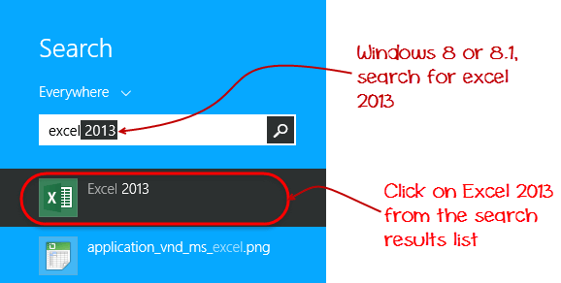

## Understanding the Ribbon

The ribbon provides shortcuts to commands in Excel. A command is an action that the user performs. An example of a command is creating a new document, printing a documenting, etc. The image below shows the ribbon used in Excel 2013.

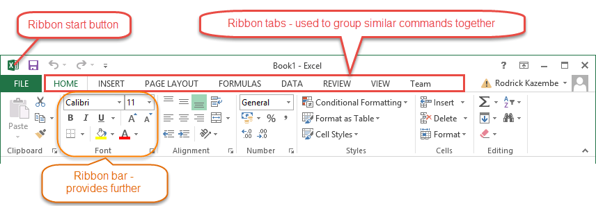

### Ribbon components explained

**Ribbon start button** – it is used to access commands i.e. creating new documents, saving existing work, printing, accessing the options for customizing Excel, etc.

**Ribbon tabs** – the tabs are used to group similar commands together. The home tab is used for basic commands such as formatting the data to make it more presentable, sorting and finding specific data within the spreadsheet.

**Ribbon bar** – the bars are used to group similar commands together. As an example, the Alignment ribbon bar is used to group all the commands that are used to align data together.

## Understanding the worksheet (Rows and Columns, Sheets, Workbooks)

**A worksheet is a collection of rows and columns**. When a row and a column meet, they form a cell. Cells are used to record data. Each cell is uniquely identified using a cell address. Columns are usually labelled with letters while rows are usually numbers.

**A workbook is a collection of worksheets**. By default, a workbook has three cells in Excel. You can delete or add more sheets to suit your requirements. By default, the sheets are named Sheet1, Sheet2 and so on and so forth. You can rename the sheet names to more meaningful names i.e. Daily Expenses, Monthly Budget, etc.

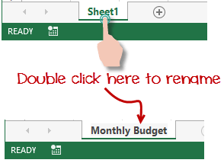

## Customization Microsoft Excel Environment

Personally I like the black colour, so my excel theme looks blackish. Your favourite colour could be blue, and you too can make your theme colour look blue-like. If you are not a programmer, you may not want to include ribbon tabs i.e. developer. All this is made possible via customizations. In this sub-section, we are going to look at;

* Customization the ribbon
* Setting the colour theme
* Settings for formulas
* Proofing settings
* Save settings

### Customization of ribbon

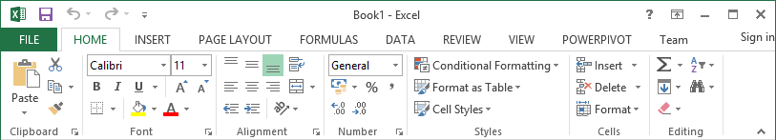

The above image shows the default ribbon in Excel 2013. Let’s start with customization the ribbon, suppose you do not wish to see some of the tabs on the ribbon, or you would like to add some tabs that are missing such as the developer tab. You can use the options window to achieve this.

* Click on the ribbon start button
* Select options from the drop down menu. You should be able to see an Excel Options dialog window
* Select the customize ribbon option from the left-hand side panel as shown below

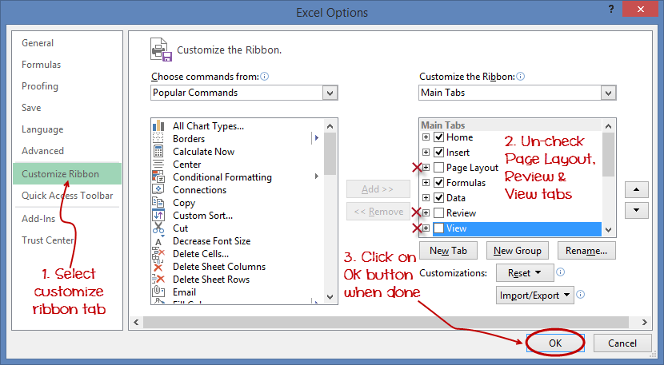

* On your right-hand side, remove the check marks from the tabs that you do not wish to see on the ribbon. For this example, we have removed Page Layout, Review, and View tab.
* Click on the “OK” button when you are done.

Your ribbon will look as follows

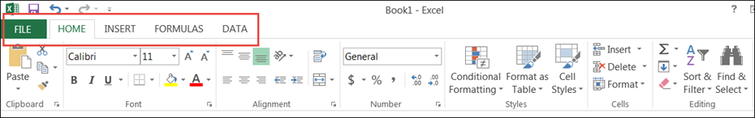

### Adding custom tabs to the ribbon

You can also add your own tab, give it a custom name and assign commands to it. Let’s add a tab to the ribbon with the text Guru99



1. Right click on the ribbon and select Customize the Ribbon. The dialogue window shown above will appear
2. Click on new tab button as illustrated in the animated image below
3. Select the newly created tab
4. Click on Rename button
5. Give it a name of Guru99
6. Select the New Group (Custom) under Guru99 tab as shown in the image below
7. Click on Rename button and give it a name of My Commands
8. Let’s now add commands to my ribbon bar
9. The commands are listed on the middle panel
10. Select All chart types command and click on Add button
11. Click on OK

Your ribbon will look as follows

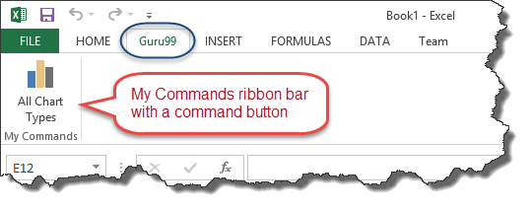

### Setting the colour theme

To set the color-theme for your Excel sheet you have to go to Excel ribbon, and click on à File àOption command. It will open a window where you have to follow the following steps.

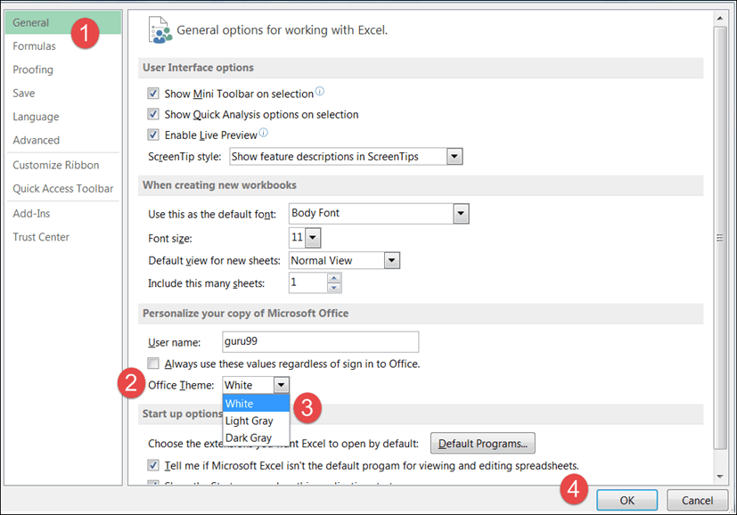

1. The general tab on the left-hand panel will be selected by default.
2. Look for colour scheme under General options for working with Excel
3. Click on the colour scheme drop-down list and select the desired colour
4. Click on OK button

### Settings for formulas

**This option allows you to define how Excel behaves when you are working with formulas**. You can use it to set options i.e. autocomplete when entering formulas, change the cell referencing style and use numbers for both columns and rows and other options.

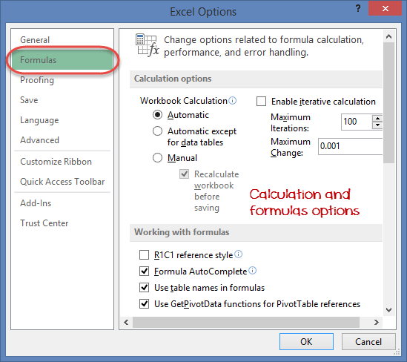

If you want to activate an option, click on its check box. If you want to deactivate an option, remove the mark from the checkbox. You can this option from the Options dialogue window under formulas tab from the left-hand side panel

### Proofing settings

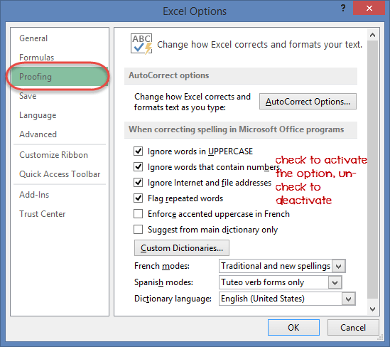

**This option manipulates the entered text entered into excel**. It allows setting options such as the dictionary language that should be used when checking for wrong spellings, suggestions from the dictionary, etc. You can this option from the options dialogue window under the proofing tab from the left-hand side panel

### Save settings

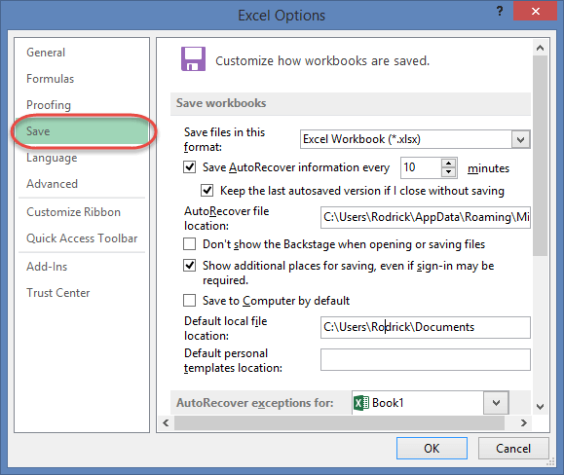

**This option allows you to define the default file format when saving files, enable auto recovery in case your computer goes off before you could save your work, etc**. You can use this option from the Options dialogue window under save tab from the left-hand side panel

## Important Excel shortcuts

|  |  |
| --- | --- |
| **Ctrl + P** | used to open the print dialogue window |
| **Ctrl + N** | creates a new workbook |
| **Ctrl + S** | saves the current workbook |
| **Ctrl + C** | copy contents of current select |
| **Ctrl + V** | paste data from the clipboard |
| **SHIFT + F3** | displays the function insert dialog window |
| **SHIFT + F11** | Creates a new worksheet |
| **F2** | Check formula and cell range covered |

## Best Practices when working with Microsoft Excel

1. Save workbooks with backward compatibility in mind. If you are not using the latest features in higher versions of Excel, you should save your files in 2003 *.xls format for backwards compatibility
2. **Use description names for columns and worksheets in a workbook**
3. **Avoid working with complex formulas with many variables**. Try to break them down into small managed results that you can use to build on
4. **Use built-in functions whenever you can instead of writing your own formulas**

## Summary

* Introduction of MS Excel : Microsoft Excel is a powerful spreadsheet program used to record, manipulate, store numeric data and it can be customized to match your preferences
* The ribbon is used to access various commands in Excel
* The options dialogue window allows you to customize a number of items i.e. the ribbon, formulas, proofing, save, etc.

### You Might Like:

* [**Excel VLOOKUP Tutorial for Beginners: Step-by-Step Examples**](https://www.guru99.com/excel-vlookup-tutorial.html)
* [**How to Import SQL Database Data into Excel File [Example]**](https://www.guru99.com/import-sql-data-excel.html)
* [**Top 10 Excel Formulas Interview Questions and Answers (2023)**](https://www.guru99.com/excel-formulas-interview-questions.html)
* [**15 BEST Excel Books (2023 Update)**](https://www.guru99.com/best-excel-books.html)
* [**11 Best FREE Microsoft Courses with Certification Online (2023)**](https://www.guru99.com/free-microsoft-courses-certifications.html)

# How to Do Addition, Subtraction, Multiplication & Division in Excel

By[Susan Gipson](https://www.guru99.com/author/susan)UpdatedDecember 23, 2022

## How To Perform Arithmetic Operations in Excel

In this tutorial, we are going to perform basic arithmetic operations i.e. addition, subtraction, division and multiplication. The following table shows the data that we will work with and the results that we should expect.

| **S/N** | **ARITHMETIC OPERATOR** | **FIRST NUMBER** | **SECOND NUMBER** | **RESULT** |
| --- | --- | --- | --- | --- |
| 1 | Addition (+) | 13 | 3 | 16 |
| 2 | Subtraction (-) | 21 | 9 | 12 |
| 3 | Division (/) | 33 | 12 | 2.75 |
| 4 | Multiplication (*) | 7 | 3 | 21 |

Let’s now use Microsoft excel to achieve the above results

### Step 1) Create an Excel Sheet and Enter the Data

Create a folder on your computer in my documents folder and name it **Guru99**Excel Tutorials

For this tutorial, we will be using Microsoft Excel 2013. The good news is even if you have Microsoft Excel 2007 or 2010, you will still be able to follow the tutorial and get the same result.

Open Excel. You will get a window similar to the one shown below. The outlook of Excel will depend on your version.

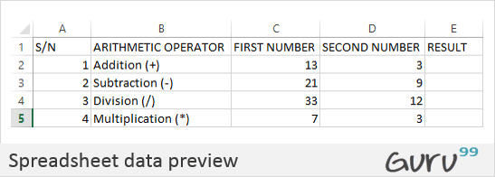

* Enter the data in your worksheet as shown in the image above.
* We will now perform the calculations using the respective arithmetic operators. When performing calculations in Excel, you should always start with the equal (=) sign.
* Let’s start with the one for addition. Write the following formula in E2 Excel (Result column)
* =C2+D2

**HERE,**

EXPLORE MORELearn Java Programming with Beginners Tutorial08:32Linux Tutorial for Beginners: Introduction to Linux Operating...01:35What is Integration Testing Software Testing Tutorial03:04What is JVM (Java Virtual Machine) with Architecture JAVA...02:24How to write a TEST CASE Software Testing Tutorial01:08Seven Testing Principles Software Testing05:01Linux File Permissions Commands with Examples13:29How to use Text tool in Photoshop CC Tutorial08:32What is NoSQL Database Tutorial02:00Important Linux Commands for Beginners Linux Tutorial15:03

* **“=”** tells Excel to evaluate whatever follows after the equal sign
* **“C2”** is the cell address of the first number given by C representing the column letter and 2 representing the row number
* **“D2”** is the cell address of the second number given by D representing the column letter and 2 representing the row number

Press enter key on the keyboard when done. You should get 16 as the result.

Using the knowledge gained in the above example, try to write the formulas for subtraction, division, and multiplication.

[**Download the above Excel Code**](https://docs.google.com/spreadsheets/d/1n7ID5-NQTO60bkKP5aqJPKqBfkBsaoF1/export?format=xlsx)

### Step 2) Format Data in Microsoft Excel

We all love beautiful things don’t we? Formatting in Excel helps us achieve exactly that. We can make our spreadsheets more presentable. We will use the data in the arithmetic operations table. We will make the column names;

* Bold
* Align serial numbers to the left
* Enclose the data in boxes.

### Step 3) Make Column Names Bold

* Highlight the cells that have the column names by dragging them.
* Click on the bold button represented by **B**command.
* Your workbook should now appear as follows

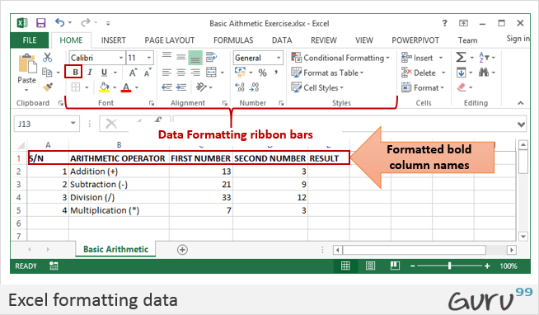

### Step 4) Align Data to the Left

* We will align the serial numbers to the left
* Highlight all the data in the S/N column
* Click on align left as shown below

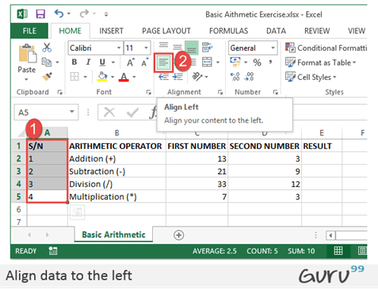

### Step 5) Enclose Data in Boxes

Highlight all the columns and rows with data

On the font ribbon bar, click on borders command as shown below.

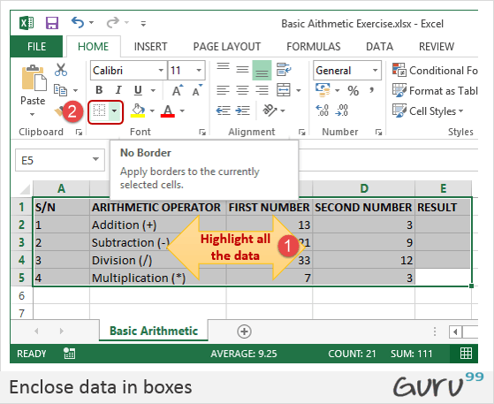

You will get the following drop down menu

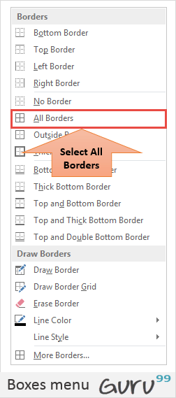

Select the option “All Borders”.

Your data should now look as follows

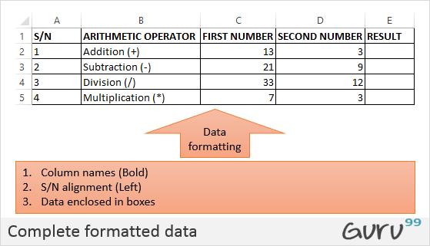

Using the knowledge gained above, try to change the font color and try out other options available on the Home tab.

### Step 6) Set the Print Area, Print Preview & Page Layout

The print area is the part of the worksheet that you would like to print out on paper. The quick and easy way of doing it is by using the following shortcut commands

Ctrl + P

You will get the following print preview.

# Data Validation in Excel: Filters, Grouping, Sorting Examples

By[Susan Gipson](https://www.guru99.com/author/susan)UpdatedDecember 23, 2022

In this tutorial, we are going to cover the following topics.

* [Data validation](https://www.guru99.com/excel-validation-filters-grouping.html#5)
* [Data filters](https://www.guru99.com/excel-validation-filters-grouping.html#6)
* [Group and Ungroup](https://www.guru99.com/excel-validation-filters-grouping.html#7)
* [Adding images to spreadsheets](https://www.guru99.com/excel-validation-filters-grouping.html#4)

## Data validation

**Data validation is very important in the sense that it helps us avoid mistakes that can be avoided**. Let’s assume you are recording student exam marks and you know the minimum is 0 and the maximum is 100. You can take advantage of validation features to ensure that only values between 0 and 100 are entered.  
Add a new sheet in your workbook by clicking on the plus button at the bottom of the worksheet.

Add a column for S/N, Name and Score. Your sheet should look as follows

|  |  |  |
| --- | --- | --- |
| **S/N** | **Name** | **Score** |
| 1 | Jane |  |
| 2 | James |  |
| 3 | Jones |  |
| 4 | Jonathan |  |
| 5 | John |  |

* Click on the DATA tab
* Select the cells C2 to C6 (The cells that will be used to record the scores)

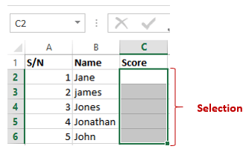

EXPLORE MORELearn Java Programming with Beginners Tutorial08:32Linux Tutorial for Beginners: Introduction to Linux Operating...01:35What is Integration Testing Software Testing Tutorial03:04What is JVM (Java Virtual Machine) with Architecture JAVA...02:24How to write a TEST CASE Software Testing Tutorial01:08Seven Testing Principles Software Testing05:01Linux File Permissions Commands with Examples13:29How to use Text tool in Photoshop CC Tutorial08:32What is NoSQL Database Tutorial02:00Important Linux Commands for Beginners Linux Tutorial15:03

* Click on Data validation drop down list.
* Click on Data validation.

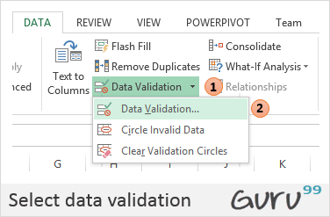

* You will get the following dialogue window

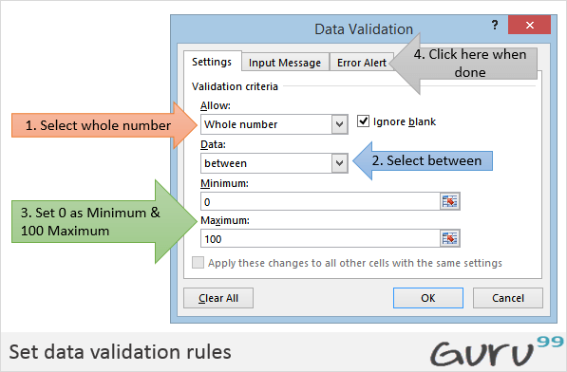

* Click on Error Alert tab
* Enter the alert title and message as shown in the diagram below.

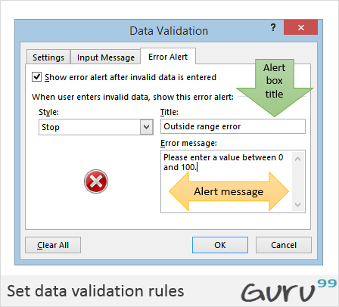

* Click on OK button
* Try to enter a score greater than 200. You will get the following error message

## Data filters

Data filters allow us to get data that matches our desired criteria. Let’s say we want to show the results of all the students whose names start with “ja” or get scores that are less than, greater than or equal to a certain value, we can use filters to get such data.  
Select the name and scores columns as shown below

* Click on DATA tab on the ribbon
* Click on Sort & Filter drop down list as shown in the image below
* Click on the Name Filter
* Select text filters
* Select begins with
* You will get the following window.
* Enter “ja” and click on “OK” button
* You should be able to see only the results for Jane and James.

## Group and Ungroup

Groups allow us to view easily and hide unnecessary details from either columns or rows. In addition to that, we can also use groups to analyse data that belongs to a common category. Let’s illustrate this with an example. We will use the student scores example above.

* Right click on the score and select insert column. Name the name column gender.
* Change James to Juanita. Put female for Janet and Juanita. Put male for the rest of the students. Your sheet should look as follows.

We will now group the females together and display their average score and do the same for the males.

* Click on DATA tab on the ribbon
* Select all the columns and rows with data
* Click on Group drop down button as shown in the image below

You will get the following window

* Make sure Rows options is selected
* Click on OK button
* You will get the following preview
* We will now calculate the average scores for females and males
* Select the whole data as shown below

Click on Subtotal drop down button under DATA tab

You will get the following window

* Set “At each change” into gender
* Set “Use function” to average
* Select “Add subtotal” to Score
* Click on “OK” button

[**Download the above Excel Code**](https://docs.google.com/spreadsheets/d/1HCpIFYA565I2NgDkikbpDRg8SoNHcuCf/export?format=xlsx)

## Adding images to spreadsheets

At times, you would like to brand the documents printed in excel with letterhead information and print with the company logo, etc. Excel has features that allow you to import images into Excel. The command for adding images is found under the INSERT tab on the ribbon.

You will get the following dialogue window

* You can browse to any folder on your computer that has pictures, and you can select any picture of your choice.
* You will get results similar to the ones shown below

### Tutorial exercise 4

Use the INSERT tab pictures command to add a picture of your choice to the worksheet.

## Summary

In this article, we have learnt how to perform basic arithmetic operations using Excel, format the data, and apply validation rules, filter data and how to take advantage of groups to further analyse data and improve presentation.

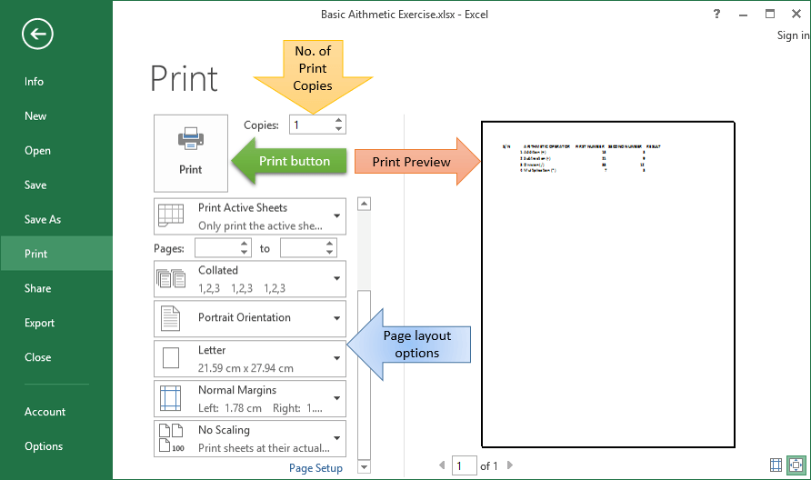

Press Esc button to exit print preview mode

The page setup ribbon bar has a number of options i.e. orientation, size, etc. Try to apply the different settings and use Ctrl + P shortcut to preview the effects on the worksheet.

## Tutorials Data

For this tutorial, we will work with the following datasets.

**Home supplies budget**

| **S/N** | **ITEM** | **QTY** | **PRICE** | **SUBTOTAL** | **Is it Affordable?** |
| --- | --- | --- | --- | --- | --- |
| 1 | Mangoes | 9 | 600 |  |  |
| 2 | Oranges | 3 | 1200 |  |  |
| 3 | Tomatoes | 1 | 2500 |  |  |
| 4 | Cooking Oil | 5 | 6500 |  |  |
| 5 | Tonic Water | 13 | 3900 |  |  |

**House Building Project Schedule**

| **S/N** | **ITEM** | **START DATE** | **END DATE** | **DURATION (DAYS)** |
| --- | --- | --- | --- | --- |
| 1 | Survey land | 04/02/2015 | 07/02/2015 |  |
| 2 | Lay Foundation | 10/02/2015 | 15/02/2015 |  |
| 3 | Roofing | 27/02/2015 | 03/03/2015 |  |
| 4 | Painting | 09/03/2015 | 21/03/2015 |  |

## What is Formulas in Excel?

**FORMULAS IN EXCEL**is an expression that operates on values in a range of cell addresses and operators. For example, =A1+A2+A3, which finds the sum of the range of values from cell A1 to cell A3. An example of a formula made up of discrete values like =6*3.

=A2 * D2 / 2

**HERE,**

* "=" tells Excel that this is a formula, and it should evaluate it.
* "A2" * D2" makes reference to cell addresses A2 and D2 then multiplies the values found in these cell addresses.
* "/" is the division arithmetic operator
* "2" is a discrete value

### Formulas practical exercise

We will work with the sample data for the home budget to calculate the subtotal.

* Create a new workbook in Excel
* Enter the data shown in the home supplies budget above.
* Your worksheet should look as follows.

We will now write the formula that calculates the subtotal

Set the focus to cell E4

Enter the following formula.

=C4*D4

**HERE,**

* "C4*D4" uses the arithmetic operator multiplication (*) to multiply the value of the cell address C4 and D4.

Press enter key

You will get the following result

The following animated image shows you how to auto select cell address and apply the same formula to other rows.

## Mistakes to avoid when working with formulas in Excel

1. Remember the rules of Brackets of Division, Multiplication, Addition, & Subtraction **(BODMAS).** This means expressions are brackets are evaluated first. For arithmetic operators, the division is evaluated first followed by multiplication then addition and subtraction is the last one to be evaluated. Using this rule, we can rewrite the above formula as =(A2 * D2) / 2. This will ensure that A2 and D2 are first evaluated then divided by two.
2. Excel spreadsheet formulas usually work with numeric data; you can take advantage of data validation to specify the type of data that should be accepted by a cell i.e. numbers only.
3. To ensure that you are working with the correct cell addresses referenced in the formulas, you can press F2 on the keyboard. This will highlight the cell addresses used in the formula, and you can cross check to ensure they are the desired cell addresses.
4. When you are working with many rows, you can use serial numbers for all the rows and have a record count at the bottom of the sheet. You should compare the serial number count with the record total to ensure that your formulas included all the rows.

Check Out  
[Top 10 Excel Spreadsheet Formulas](https://career.guru99.com/top-10-excel-formulas-asked-in-an-interview/)

## What is Function in Excel?

**FUNCTION IN EXCEL** is a predefined formula that is used for specific values in a particular order. Function is used for quick tasks like finding the sum, count, average, maximum value, and minimum values for a range of cells. For example, cell A3 below contains the SUM function which calculates the sum of the range A1:A2.

* **SUM** for summation of a range of numbers
* **AVERAGE** for calculating the average of a given range of numbers
* **COUNT** for counting the number of items in a given range

## The importance of functions

**Functions increase user productivity when working with excel**. Let’s say you would like to get the grand total for the above home supplies budget. To make it simpler, you can use a formula to get the grand total. Using a formula, you would have to reference the cells E4 through to E8 one by one. You would have to use the following formula.

= E4 + E5 + E6 + E7 + E8

With a function, you would write the above formula as

=SUM (E4:E8)

As you can see from the above function used to get the sum of a range of cells, it is much more efficient to use a function to get the sum than using the formula which will have to reference a lot of cells.

## Common functions

Let’s look at some of the most commonly used functions in ms excel formulas. We will start with statistical functions.

| **S/N** | **FUNCTION** | **CATEGORY** | **DESCRIPTION** | **USAGE** |
| --- | --- | --- | --- | --- |
| 01 | SUM | Math & Trig | Adds all the values in a range of cells | =SUM(E4:E8) |
| 02 | MIN | Statistical | Finds the minimum value in a range of cells | =MIN(E4:E8) |
| 03 | MAX | Statistical | Finds the maximum value in a range of cells | =MAX(E4:E8) |
| 04 | AVERAGE | Statistical | Calculates the average value in a range of cells | =AVERAGE(E4:E8) |
| 05 | COUNT | Statistical | Counts the number of cells in a range of cells | =COUNT(E4:E8) |
| 06 | LEN | Text | Returns the number of characters in a string text | =LEN(B7) |
| 07 | SUMIF | Math & Trig | Adds all the values in a range of cells that meet a specified criteria. =SUMIF(range,criteria,[sum_range]) | =SUMIF(D4:D8,”>=1000″,C4:C8) |
| 08 | AVERAGEIF | Statistical | Calculates the average value in a range of cells that meet the specified criteria. =AVERAGEIF(range,criteria,[average_range]) | =AVERAGEIF(F4:F8,”Yes”,E4:E8) |
| 09 | DAYS | Date & Time | Returns the number of days between two dates | =DAYS(D4,C4) |
| 10 | NOW | Date & Time | Returns the current system date and time | =NOW() |

## Numeric Functions

As the name suggests, these functions operate on numeric data. The following table shows some of the common numeric functions.

| **S/N** | **FUNCTION** | **CATEGORY** | **DESCRIPTION** | **USAGE** |
| --- | --- | --- | --- | --- |
| 1 | ISNUMBER | Information | Returns True if the supplied value is numeric and False if it is not numeric | =ISNUMBER(A3) |
| 2 | RAND | Math & Trig | Generates a random number between 0 and 1 | =RAND() |
| 3 | ROUND | Math & Trig | Rounds off a decimal value to the specified number of decimal points | =ROUND(3.14455,2) |
| 4 | MEDIAN | Statistical | Returns the number in the middle of the set of given numbers | =MEDIAN(3,4,5,2,5) |
| 5 | PI | Math & Trig | Returns the value of Math Function PI(π) | =PI() |
| 6 | POWER | Math & Trig | Returns the result of a number raised to a power. **POWER( number, power )** | =POWER(2,4) |
| 7 | MOD | Math & Trig | Returns the Remainder when you divide two numbers | =MOD(10,3) |
| 8 | ROMAN | Math & Trig | Converts a number to roman numerals | =ROMAN(1984) |

## String functions

These basic excel functions are used to manipulate text data. The following table shows some of the common string functions.

| **S/N** | **FUNCTION** | **CATEGORY** | **DESCRIPTION** | **USAGE** | **COMMENT** |
| --- | --- | --- | --- | --- | --- |
| 1 | LEFT | Text | Returns a number of specified characters from the start (left-hand side) of a string | =LEFT(“GURU99”,4) | Left 4 Characters of “GURU99” |
| 2 | RIGHT | Text | Returns a number of specified characters from the end (right-hand side) of a string | =RIGHT(“GURU99”,2) | Right 2 Characters of “GURU99” |
| 3 | MID | Text | Retrieves a number of characters from the middle of a string from a specified start position and length. **=MID (text, start_num, num_chars)** | =MID(“GURU99”,2,3) | Retrieving Characters 2 to 5 |
| 4 | ISTEXT | Information | Returns True if the supplied parameter is Text | =ISTEXT(value) | value – The value to check. |
| 5 | FIND | Text | Returns the starting position of a text string within another text string. This function is case-sensitive. **=FIND(find_text, within_text, [start_num])** | =FIND(“oo”,”Roofing”,1) | Find oo in “Roofing”, Result is 2 |
| 6 | REPLACE | Text | Replaces part of a string with another specified string. **=REPLACE (old_text, start_num, num_chars, new_text)** | =REPLACE(“Roofing”,2,2,”xx”) | Replace “oo” with “xx” |

## Date Time Functions

These functions are used to manipulate date values. The following table shows some of the common date functions

| **S/N** | **FUNCTION** | **CATEGORY** | **DESCRIPTION** | **USAGE** |
| --- | --- | --- | --- | --- |
| 1 | DATE | Date & Time | Returns the number that represents the date in excel code | =DATE(2015,2,4) |
| 2 | DAYS | Date & Time | Find the number of days between two dates | =DAYS(D6,C6) |
| 3 | MONTH | Date & Time | Returns the month from a date value | =MONTH(“4/2/2015”) |
| 4 | MINUTE | Date & Time | Returns the minutes from a time value | =MINUTE(“12:31”) |
| 5 | YEAR | Date & Time | Returns the year from a date value | =YEAR(“04/02/2015”) |

## VLOOKUP function

The VLOOKUP function is used to perform a vertical look up in the left most column and return a value in the same row from a column that you specify. Let’s explain this in a layman’s language. The home supplies budget has a serial number column that uniquely identifies each item in the budget. Suppose you have the item serial number, and you would like to know the item description, you can use the VLOOKUP function. Here is how the VLOOKUP function would work.

=VLOOKUP (C12, A4:B8, 2, FALSE)

**HERE,**

* "=VLOOKUP" calls the vertical lookup function
* "C12" specifies the value to be looked up in the left most column
* "A4:B8" specifies the table array with the data
* "2" specifies the column number with the row value to be returned by the VLOOKUP function
* "FALSE," tells the VLOOKUP function that we are looking for an exact match of the supplied look up value

The animated image below shows this in action

[**Download the above Excel Code**](https://docs.google.com/spreadsheets/d/1DyNw7uLpQcOVLF9SVjwKYozGyymWB4XZ/export?format=xlsx)

## Summary

Excel allows you to manipulate the data using formulas and/or functions. Functions are generally more productive compared to writing formulas. Functions are also more accurate compared to formulas because the margin of making mistakes is very minimum.

## Here is a list of important Excel Formula and Function

* SUM function = =SUM(E4:E8)
* MIN function = =MIN(E4:E8)
* MAX function = =MAX(E4:E8)
* AVERAGE function = =AVERAGE(E4:E8)
* COUNT function = =COUNT(E4:E8)
* DAYS function = =DAYS(D4,C4)
* VLOOKUP function = =VLOOKUP (C12, A4:B8, 2, FALSE)
* DATE function = =DATE(2020,2,4)